Curricular Unit Literature
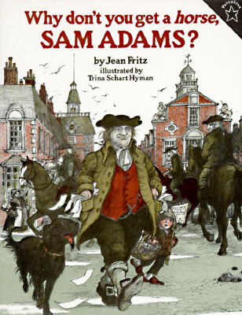 | Title: Why don’t you get a horse, Sam Adams?  Author/Illustrator: Jean Fritz, illustrated by Trina S. Hyman  Copyright date: 2009  Publisher: Puffin Books  Genre or theme (i.e. Caldecott, Biography etc.): Historical Non-Fiction  Brief description of book content (or Summary in your own words): A student friendly account of the American Revolution and the role that Samuel Adams played in it. It is a fun story that gives history a friendly and lively voice.  Personal & Classroom Connection (2 sentences): This book could be read aloud in sections, or assigned to the students to read. It gives history a student friendly view of the role that Sam Adams played in the American Revolution. (This text came with our newly purchased ELA curriculum.)
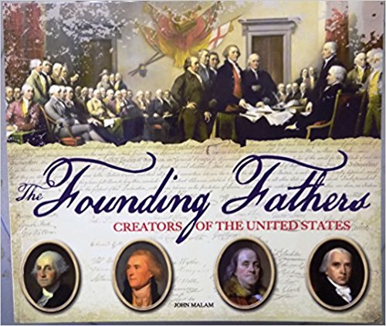 | Title: The Founding Fathers  Author/Illustrator: John Malam  Copyright date: 2014  Publisher: Scholastic, Inc.  Genre or theme (i.e. Caldecott, Biography etc.):  Historical Non-Fiction  Brief description of book content (or Summary in your own words): The book accounts for the lives of many of the founding fathers of the United States that signed the Declaration of Independence and the U.S. Constitution. There are also many of the supporting people who helped the revolution.  Personal & Classroom Connection (2 sentences): I would use this text as a read aloud, read in sections. I would also have the students read selected sections about the historical figures in order to answer comprehension questions and to find pertinent information for lessons within this unit.
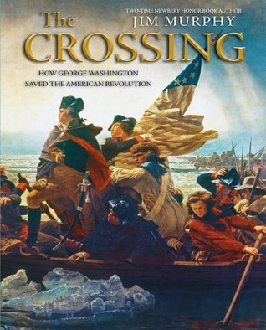 | Title: The Crossing: How George Washington saved the American Revolution  Author/Illustrator: Jim Murphy  Copyright date: 2010  Publisher: Scholastic Press  Genre or theme (i.e. Caldecott, Biography etc.): Historical Non-Fiction, Biography  Brief description of book content (or Summary in your own words): This text is a narrative account of the stages of the American Revolution. Of course, it centers around the actions of George Washington and the actions that he took to defeat the British invasion.  Personal & Classroom Connection (2 sentences): I would use this text as a read aloud, and as a reference text. I would take advantage of the sequential layout of this book to have students find information and to build a timeline of events that occurred during the revolution.
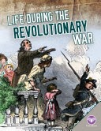 | Title: Life during the Revolutionary War  Author/Illustrator: Bonnie Hinman  Copyright date: 2015  Publisher: Abdo Publishing  Genre or theme (i.e. Caldecott, Biography etc.): Historical Non-Fiction  Brief description of book content (or Summary in your own words): This book details the life of the settlers during the times of the Revolutionary War. This text is very informative and descriptive about the hardships and responsibilities that the colonists had to endure in order to survive.  Personal & Classroom Connection (2 sentences): This short text could be used as a read aloud or an informational source for unit lessons that require knowledge about the lives (work, school, family, apprenticeships) of the settlers.
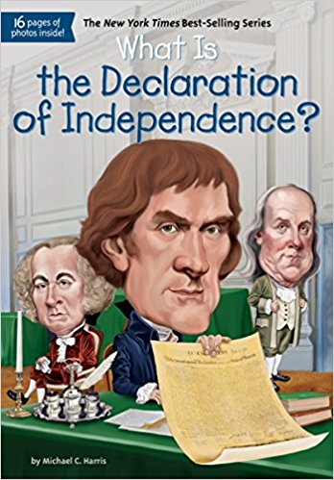 | Title: What is the Declaration of Independence?  Author/Illustrator: Michael C. Harris (author), Who HQ (author), Jerry Hoare (illustrator)  Copyright date: 2016  Publisher: Penguin Workshop  Genre or theme (i.e. Caldecott, Biography etc.): Historical Fiction  Brief description of book content (or Summary in your own words): After the French and Indian War, King George III felt the colonists should help pay the debt that was incurred. The Revolutionary War had already begun, but for two weeks Thomas Jefferson conferred with other men to write their declaration to the King that they were breaking away from Britain to become a new nation.  Personal & Classroom Connection (2 sentences): Bringing a timeline to life, this historical fiction book breaths life into event that students are learning about by placing them vicariously there with the signers of the Declaration. This book will create a connection to the unit by tying together events.
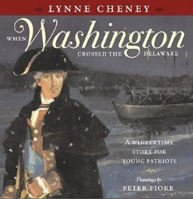 | Title: When Washington crossed the Delaware  Author/Illustrator: Lynne Cheney illustrations/paintings by Peter M. Fiore  Copyright date: 2012  Publisher: Simon & Schuster Books for Simon & Schuster Books for Young Readers  Genre or theme (i.e. Caldecott, Biography etc.): Historical Non-Fiction, Biography  Brief description of book content (or Summary in your own words): An account of the Christmas Night decision to cross the Delaware River and launch a surprise attack against the British troops.  Personal & Classroom Connection (2 sentences): This book can be as a supplemental text for instruction about the timeline of the Revolutionary War. It is focused around acts of George Washington, but if has loads of information about events leading up to, during, and after the revolution. (This text came with our newly purchased ELA curriculum.)
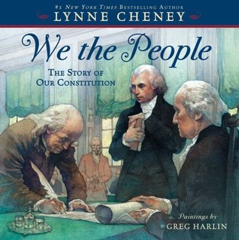 | Title: We the People  Author/Illustrator: Lynne Cheney, illustrator Greg Harlin  Copyright date: 2008  Publisher: Simon & Schuster Children’s Publishing  Genre or theme (i.e. Caldecott, Biography etc.): Historical Non-Fiction  Brief description of book content (or Summary in your own words): The Constitution of the United States was written by several important people. George Washington, James Madison, Benjamin Franklin and many others all gathered together in Philadelphia May 1787 to create a new framework for a struggling new country. Their efforts helped the United States become a powerful force in the future to come.  Personal & Classroom Connection (2 sentences): As a supplemental text this book can be used in small groups and as a read aloud. It have information that will help to enforce the instructional lesson throughout the unit.
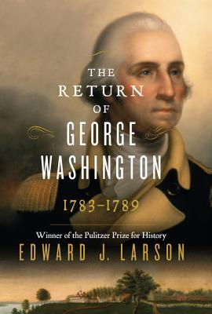 | Title: The Return of George Washington 1783-1789  Author/Illustrator: Edward J. Larson  Copyright date: 2014  Publisher: William Morrow  Genre or theme (i.e. Caldecott, Biography etc.): Historical Non-Fiction, Biography  Brief description of book content (or Summary in your own words): George Washington had retired from the Revolutionary War and from the Army, but he was drawn back into service with the need for leadership. The Constitutional Convention was floundering and he was asked to step up and lead. George Washington did honor the request and he lead the young country in a positive direction, soon after that he became the first President of the United States.  Personal & Classroom Connection (2 sentences): During the instruction of the unit this book can act as a supplemental text of the actions of an individual man and his influences over the many to create a solid democracy.
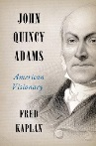 | Title: John Quincy Adams: American Visionary  Author/Illustrator: Fred Kaplan  Copyright date: 2014  Publisher: Harper  Genre or theme (i.e. Caldecott, Biography etc.): Historical Non-Fiction, Biography  Brief description of book content (or Summary in your own words): John Quincy Adams was a young man during the American Revolution, he served as Secretary of State for a young United States, and eventually he served as our 6th President. This book follows his thinking and his passion for a young country. He had an eloquent way with words both spoken and written, and that was very evident in the mark that he left on our country.  Personal & Classroom Connection (2 sentences): This book can be used as a supplemental text to the instruction about the founding fathers, early presidents, and the creators of the Declaration of Independence. Students whom are on grade level reading will be able to read it and gather information, and read it aloud for peers.
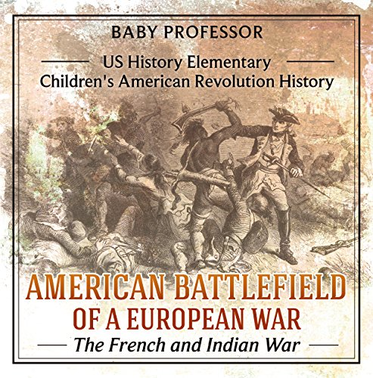 | Title: American Battlefield of a European War- The French and Indian War  Author/Illustrator: Baby Professor  Copyright date: 2017  Publisher: Amazon Digital Services, LLC.  Genre or theme (i.e. Caldecott, Biography etc.): Historical Non-Fiction  Brief description of book content (or Summary in your own words): A visual representation of the French and Indian war. Identifies that the war has a misleading name and offers clarity and simplification of understanding of the war.  Personal & Classroom Connection (2 sentences): To accompany the French and Indian war lesson, giving a simplified version to follow a longer, more in depth read aloud. The visuals add another dimension for deeper understanding.
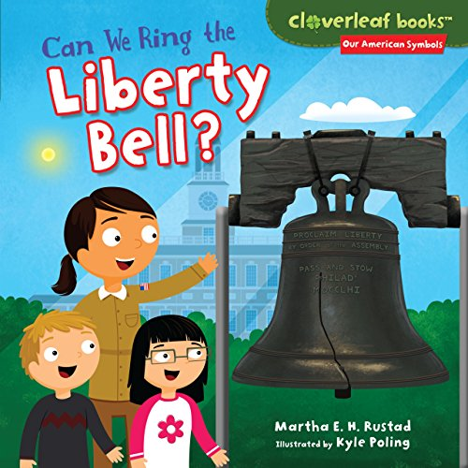 | Title: Can We Ring the Liberty Bell?  Author/Illustrator: By Martha E. H. Rustad, Illustrated by Kyle Poling  Copyright date: 2014  Publisher: Millbrook Press  Genre or theme (i.e. Caldecott, Biography etc.): Historical fiction  Brief description of book content (or Summary in your own words): Mr. Chen’s class takes a field trip to see the Liberty Bell. They learn about how it got it’s crack and that it was rung for the reading of the Declaration of Independence. The Declaration said America wanted to be it’s own country. Their ranger guide asks them in a riddle to ring the bell of freedom, but they aren’t able to ring a bell that is broken. The children come up with ideas of how to ring the bell of freedom by being fair and making sure people have choices.  Personal & Classroom Connection (2 sentences): This book can be used to make the symbolic connection between the liberty bell and our country’s independence. Children will recognize their role in protecting freedom by being fair and providing and honoring chtoices.
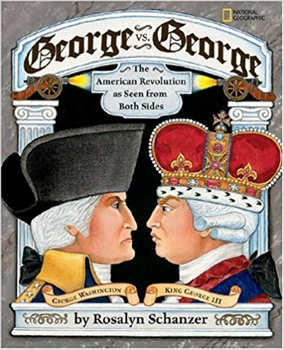 | Title: George vs. George: The American Revolution as Seen from Both Sides  Author/Illustrator: Rosalyn Schanzer  Copyright date: 2007 Reprint edition  Publisher: National Geographic Children's Books  Genre or theme (i.e. Caldecott, Biography etc.): Historical non-fiction  Brief description of book content (or Summary in your own words): This book gives background information of the Commander in Chief, George, and King George III. It also gives information on the events that led to the American Revolution. The cartoon characters make it student friendly and gives lots of information about the soldiers who fought in the war and what happened after the war.  Personal & Classroom Connection (2 sentences): Students will be able to use this book as a resource for information about the American Revolution and the two sides of the war. It can be used to understand the two types of government the colonists were facing and who they chose to follow.

