The American Revolution – Module 4: Lesson 3

Topic: Let Freedom Ring |  | Grade: 5th grade
Standards:
H2.5.6 Identify the events that led to the Declaration of Independence.
H2.5.7 Identify the causes, key events, and people of the American Revolution.
RI.5.1 Quote accurately from a text when explaining what the text says explicitly and when drawing inferences from the text.
RI.5.2 Determine two or more main ideas of a text and explain how they are supported by key details; summarize the text.
RI.5.3 Explain the relationships or interactions between two or more individuals, events, ideas, or concepts in a historical, scientific, or technical text based on specific information in the text.

Lesson Objective(s):  I know the essential ideas of American democratic government that are expressed in the Declaration of Independence  I can list some basic values and principles that Americans share.  Know: Students will know that the Liberty Bell is a symbol for Freedom. They will know the ideas that were expressed in the Declaration.  Do: Students will participate in a student-led discussion, create a Waterfall Graphic Organizer, and build a craft for our living timeline.  How: Activities are based on responses to reading, close reading, and organizing structures to make thinking visible. |  |  | Formative Assessment(s)  Waterfall graphic organizer with essential ideas of American democratic government.  Accountable Talk discussion on what America might be like if the colonists decided to not declare their independence.  Small group activity using thinking routine: Generate – Sort – Connect - Elaborate  How:  Students will use selections from a chapter book, a picture book, and multimedia to learn more and interact with historical questions from the Declaration of Independence and today.
Duration: 2 days with 40 minute time blocks
Materials:
Tin foil square (for each student)
Toilet paper role (for each student)
Styrofoam cup (for each student)
Bell (for each student)
Pipe cleaner (for each student)
Foldable Waterfall Graphic Organizer (for each student)
Sticky notes
Accountable Talk Stems
Technology:
BrainPop: Declaration of Independence
https://www.brainpop.com/socialstudies/ushistory/declarationofindependence/
Rationale:
This lesson presents connects reasoning for why the colonists declared their independence. The narrative connection helps students consider what it would have been like to be there during these revolutionary times. It will give students a broader perspective of how others’ choices affect us today.

Hook:
Read aloud and discuss using a thinking routine to categorize reasoning in small groups.

Essential Questions:
What were some of the advantages or disadvantages of declaring freedom from Britain?
Would you have signed the Declaration of Independence?
What would America be like if the colonists had not declared their independence from Britain?

Time | Procedures
Day 1  40 min  (5 min)  (2 min)  (5 min)  (3 min)  (5 min)  (20 min)  Day 2  40 min  (10 min)  (30 min)  Day 3  (10 min)  (20 min)  (10 min) | Concept Development:  Read aloud: “The King Must Go” – Chapter 7  Generate-Sort-Connect-Elaborate  Generate: In small groups of 4-5 students, generate a list of ideas that come to mind about the colonists wanting to be free of the king. Each idea will be written on a sticky note and placed on the large poster paper in their group. (2 minutes)  Sort: Sort the sticky notes in web form by having central ideas in the center and supportive ideas around the central ideas.  Connect: Connect supporting ideas to central ideas by drawing lines to link them together.  Elaborate: Add some new ideas that extend your thinking and improve what you are wanting to explain.  Share: Choose a spokesperson from each team to explain one main idea and connecting details. Each group will have a turn to share.  Review of historical events:  BrainPop: Declaration of Independence  Read aloud: “Declaring Freedom” – Chapter 8  Close read p. 78 - 79 and create a waterfall graphic organizer to analyze the four parts of the declaration of independence. The top page should have a title and the last page will be used as a reflection about whether or not they would have signed the declaration of independence and why.  Closing  Read Can We Ring the Liberty Bell? By Martha E. H. Rustad  Student-led class discussion on what America might be like if the colonists decided to not declare their independence.  Make a Liberty Bell artifact and write a paragraph on how they can do their part to ring the Liberty Bell.
Review:
Review historical events leading up to the Declaration of Independence with a BrainPop video.
https://www.brainpop.com/socialstudies/ushistory/declarationofindependence/
Closure:
Living Timeline Artifact: Liberty Bell Craft
http://easypreschoolcraft.blogspot.com/2012/06/4th-of-july-liberty-bell-cup-craft.html?m=1
 | Parent Connection/Involvement: Parent support would be wonderful in helping students create their foldable graphic organizer.
Interdisciplinary – other subjects across the curriculum tied (if applicable)
Reading, writing, speaking and listening standards are being utilized in conjunction with Social Studies.

Foldable Waterfall Graphic Organizer
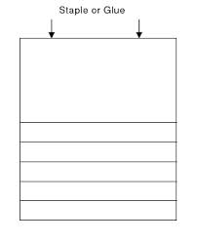

Fold three pieces of paper so that they are staggered in this waterfall pattern. Staple the top to secure the pages together.

Liberty Bell Craft

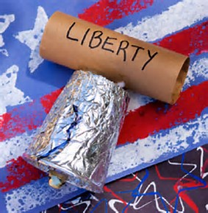

Poke 2 holes in toilet paper roll and two in the top of the Styrofoam cup. Cover the cup in tin foil and string the pipe cleaner through the matching holes in the cup and toilet paper role. Attach the bell to the two ends of the pipe cleaner and twist to secure.

Thinking Routine: Generate – Sort – Connect - Elaborate

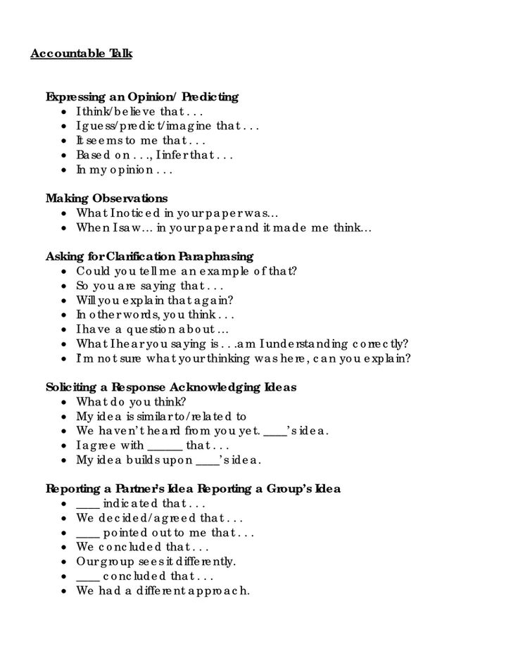
Accountable Talk Stems

References

Accountable Talk Stems. (n.d.). Retrieved November 15, 2017, from http://i.pinimg.com/736x/bd/d9/45/bdd945a91e0cb968f6ceaee2d5aef6b0.jpg.
Generate-Sort-Connect-Elaborate Thinking Routine. (n.d.). Retrieved from http://www.visiblethinkingpz.org/VisibleThinking_html_files/VisibleThinking1.html.
Liberty Bell Craft. (n.d.). Retrieved from http://easypreschoolcraft.blogspot.com/2012/06/4th-of-july-liberty-bell-cup-craft.html?m=1.

