The American Revolution – Module 4: Lesson 2

Topic: Dictator or Democracy |  | Grade: 5th grade
Standards:
H2.5.6 Identify the events that led to the Declaration of Independence.
H2.5.7 Identify the causes, key events, and people of the American Revolution.
RI.5.1 Quote accurately from a text when explaining what the text says explicitly and when drawing inferences from the text.
RI.5.2 Determine two or more main ideas of a text and explain how they are supported by key details; summarize the text.
RI.5.3 Explain the relationships or interactions between two or more individuals, events, ideas, or concepts in a historical, scientific, or technical text based on specific information in the text.

Lesson Objective(s):  I can discern the differences and similarities between a dictatorship and a democracy.  I can identify the different soldiers that fought in the American Revolution and what they were fighting for.  Know: Students will look at leadership styles to know what each one represents. They will also know what the Continental Congress was making requests as democratic representatives of the colonists.  Do: Model two different leadership styles through a game. Participate in a thinking routine to make thinking process of two leadership styles visible. Make reading and writing entries in an interactive notebook. Add a concept to a living timeline with three different types of soldiers and the leadership styles they were following.  How: Use an object lesson game: “Front-end Alignment: American Revolution”, interactive notebook entries, reading excerpts, and “Think-Puzzle-Explore” thinking routine to meet lesson objectives. |  |  | Formative Assessment(s)  -2 interactive notebook entries and reflections  -living timeline entry  How: see attachments for “Front-end Alignment: American Revolution” and thinking routine: “Think-Puzzle-Explore”.
Duration: 2 days with 40 minute time blocks

Materials: sticky notes, pie tin, duct tape, hard candy, excerpts from Life During the Revolutionary War and from The American Revolution for Kids, pictures of a Patriot soldier, Red Coat soldier, and Hessian soldier, interactive writing notebook.
Technology:
The Smithsonian’s National Museum of American History:
Regimental Uniform Coat of Colonel Peter Gansevoort Jr., Colonial soldier: http://americanhistory.si.edu/collections/search/object/nmah_439538
Eli Dagworthy’s Redcoat:
http://amhistory.si.edu/militaryhistory/exhibition/flash.html?path=1.2.r_156
Hessian Miter Cap
http://amhistory.si.edu/militaryhistory/exhibition/flash.html?path=1.5.r_320
Rationale:
This lesson connects the cognitive reasoning for why the colonists wanted to have a new form of government. It will give students a sense of self and how they would want to be governed.

Hook: Adapted- “Front End Alignment Game” – identifying two different styles of leadership or government

Essential Questions:
Why did the colonists want representation in parliament?
Why were the British and Rebel forces fighting?
What did the delegates of the Continental Congresses want from parliament and King George III?

Time | Procedures
Day 1  30 min  10 min  Day 2  20 min  10 min  10 min  Day 3  20 min  20 min. | Concept Development:  Front End Alignment Game and discussion  Read George vs. George: The American Revolution as seen from Both Sides by Rosalyn Schanzer p. 18 - 22. Students will respond to the reading by writing a brief response using the essential question: Why did the colonists want representation in parliament?  Connection and Closing:  Think-Puzzle-Explore: 1. What do you think you know about different types of leadership?  -Create categories for a “King” and “Democracy” t-chart.  -Students write what they know about a king on a sticky note and what they know about a democracy on another sticky note.  -When all notes are collected, quickly cluster notes in to similar strains of thought. Read through the notes as they are grouped together.  Think-Puzzle-Explore: 2. What questions or puzzles do you have about different types of leadership?  -Give students a chance to ask questions. Without judgement or answers, write the questions out for students to reference throughout the unit.  Think-Puzzle-Explore: 3. What do different types of leadership make you want to explore?  -Have students create a list in their Social Studies notebooks of things they would like to learn more about after this game, discussion, and thinking routine.  Read excerpt from George vs. George: The American Revolution as seen from Both Sides by Rosalyn Schanzer p. 32-35. Using the text as a guide, respond to reading in Social Studies notebooks by answering the essential question: Why were the British and Rebel forces fighting?  Closing activity: Color three soldiers, a Patriot, a Red Coat, and a Hessian, for their living time-line. Have students label the soldiers and what leader they were following, King George or George Washington.  Concept Development:  Read aloud: “What is the Declaration of Independence?” – Chapter 2  Discussion: Use Accountable Talk Stems to support a student-lead discussion about the advantages and disadvantages of breaking away from Britain.  Connection and Closing:  Students will create a protest poster using quotes from the book, “What is the Declaration of Independence?” – Chapter 2, expressing colonists’ outrage: (ex. “Taxation without representation is tyranny!” – p. 72)
 | Review: The thinking routine Think-Puzzle-Explore will help students reflect on the different styles of leadership they are learning about between King George III and the colonial democracy established by the Continental Congresses.
 | Closure: Color three soldiers, a Patriot, a Red Coat, and a Hessian, for their living time-line. Have students label the soldiers and what leader they were following.
 | Parent Connection/Involvement: Parent involvement would be helpful during the “Front End Alignment” game. Parents could offer support to team leaders by instructing them in their role as a “king” or a democratic leader.
Interdisciplinary – other subjects across the curriculum tied (if applicable)
Reading and writing activities are included using interactive notebooks.

Extension: Read The Crossing by Jim Murphy
George Washington was the Commander and Chief of the Revolution Army. Write an essay about the type of leader he was according to your research from this book. Quote accurately from the text and explain what lesson the author is trying to teach about George Washington.
“Front-End Alignment Game”
Adapted
Equipment: Pie tins (1 per group)
3 pieces of hard candy per student
Duct tape

How to Play:

Leadership Style 'A'

You are the king You are in charge. You know what is best for your team, who represents your people. You must take control of your people to lead them to victory. You believe that information is power and that you must maintain power to maintain control. Therefore, give out little information, answer few questions, and maintain strict discipline. Strictly enforce the rules and the time limits.

You will give your team orders on how to complete the game. You will not reveal the rules to them. You will tell each person where to stand, both in practice and in the scoring round. Do not give in to complaints or whining from, members of your patrol. “Let me do it my way” or “Let me decide” are demands that indicate a desire by someone to take over your control.

You know the rules; therefore, you know the best way to win. What you say, goes. Now read the rules, implement them, and lead your team to victory!

---------------------------------------------------------------------------------------------------------------------

Leadership Style “B”

You believe in sharing decision-making with members of your team. You feel that the best way to achieve high performance and creative results is to take advantage of the full talents of everyone on your team. You want to draw on their ideas and experience, and their knowledge of their own skills and ways of finding solutions.

You think that solutions to problems can emerge from an environment that is rich in information, even if that seems chaotic.

You will share all the information you have with your team. You will tell them the rules of the game, its objectives, and the way it will be scored. Seek the ideas and creativity of the team in planning the best ways to win. Take part in discussions to overcome problems. Help the team stay within the rules and the time limits. Allow players to assess their own skill and comfort level in determining their individual scoring strategies. Be a cheerleader. Participate with your team. Recognize that everyone has a voice, like in a democracy. Have fun. Celebrate positive results.

The Rules
1. The object of the game is to score as many points as possible while staying within the rules. At the end of the game, the patrol with the most points wins.
2. The challenge is to stand somewhere on the marked tape and successfully toss pieces of candy into the container. The piece must come to rest in the container (a HIT). If the piece misses the container or bounces out, it is a MISS and no points are scored.
3. One point is scored for each HIT.
4. Distance bonus points area possible with each HIT. One bonus point is awarded for each foot of distance the player stands from the container while scoring a HIT. No distance bonus points are awarded for a MISS.
5. Each player gets three pieces of candy.
6. One practice round is allowed for scoring begins. Each player is allowed three practice tosses in the practice round. (Points will be deducted if participants practice beyond the rules.)
7. Once scoring begins, each player may toss each piece of candy one time- a total of three tosses per participant.
8. The observer does the scoring.
9. The patrol leader is in charge at all times.
10. The patrol must complete the practice round and scoring round in no more than 10 minutes.
11. These are the rules. The observer will remain silent throughout the game and will not reveal your score until the game is over. NOTE: The scouts can use anything in the room as long as the follow the rules listed above.

Reflection

(Ask students to sit where they are for this discussion.) A student-led discussion will take place on how students felt about this type of leadership. This may be the toughest reflection that you do. First of all, it is the first one you will do. Secondly, you may receive criticism. You have purposely played the role of “King” which probably is a role these students see some adults and leaders play in their lives. They may be hostile to this type of leadership. If they confront some adults, they often meet resistance and punishment.

Your job is to help them see the role of the King as the colonists viewed King George as he began taxing colonists to pay for debts incurred from the French and Indian War. Here are some sample questions you might ask.
1. Who took a leadership role in solving this problem? (What happened?)
2. How did decisions get made? (What happened?)
3. What kind of leader did I portray? (Make a judgment.)
4. What didn’t you like about this style of leader? (Make a judgment.)
5. How does it feel to be led by a “king”? (Generalize.)

THINK / PUZZLE / EXPLORE

A routine that sets the stage for deeper inquiry

Purpose: What kind of thinking does this routine encourage? This routine activates prior knowledge, generates ideas and curiosity and sets the stage for deeper inquiry.

Application: When and where can it be used? This routine works especially well when introducing a new topic, concept or theme in the classroom. It helps students take stock of what they already know and then pushes students to identify puzzling questions or areas of interest to pursue. Teachers can get a good sense of where students are on a conceptual level and, by returning to the routine over the course of study, they can identify development and progress. The third question is useful in helping students lay the ground work for independent inquiry.

Launch: What are some tips for starting and using this routine? With the introduction of new topic—for example, earth, leaves, fractions, Buddhism—the class can engage in the routine together to create a group list of ideas. Between each phase of the routine, that is with each question, adequate time needs to be given for individuals to think and identify their ideas. You may even want to have students write down their individual ideas before sharing them out as a class. In some cases, you may want to have students carry out the routine individually on paper or in their heads before working on a new area.

Keep a visible record of students’ ideas. If you are working in a group, ask students to share some of their thoughts and collect a broad list of ideas about the topic on chart paper. Or students can write their individual responses on post-it notes and later add them to a class list of ideas.

Note that it is common for students to have misconceptions at this point—include them on the list so all ideas are available for consideration after further study. Students may at first list seemingly simplistic ideas and questions. Include these on the whole class list but push students to think about things that are truly puzzling or interesting to them.

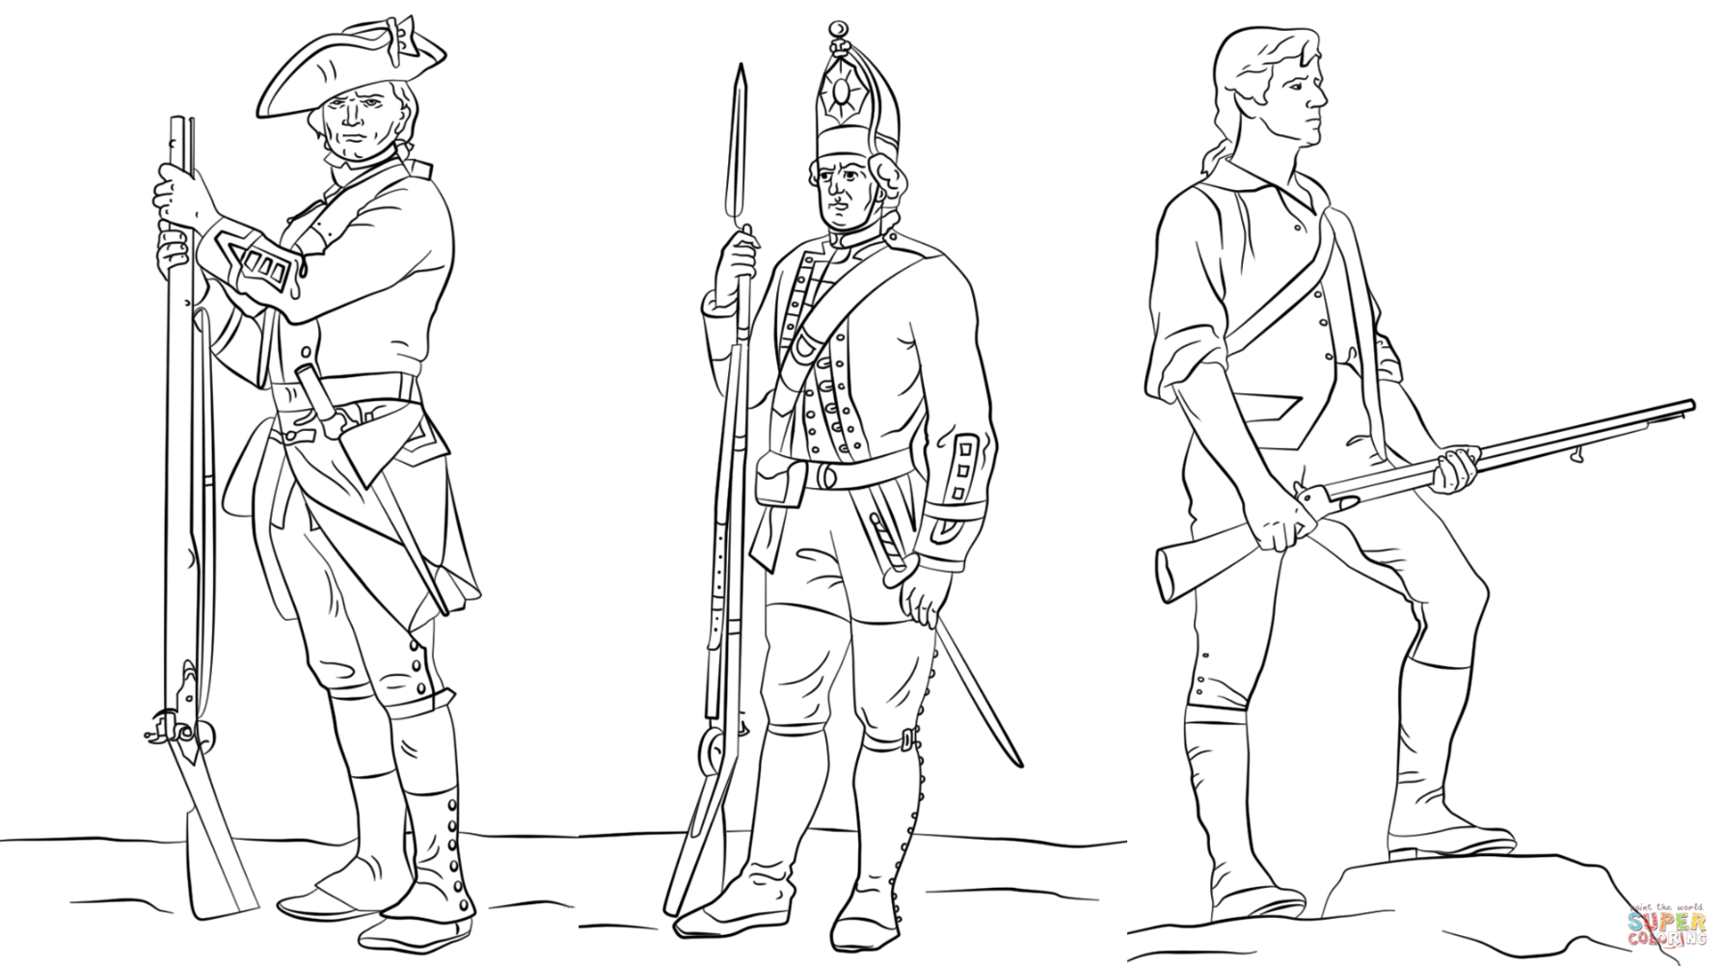
British (Red Coat) Soldier
Hessian Soldier
Minute Man Colonial Soldier

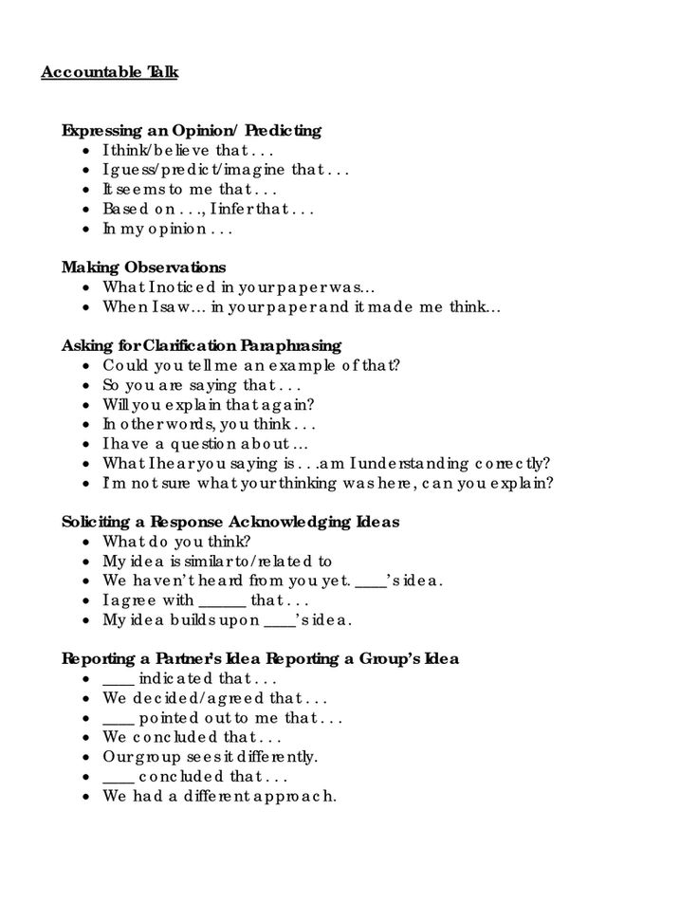
Accountable Talk Stems

References

Accountable Talk Stems. (n.d.). Retrieved November 15, 2017, from http://i.pinimg.com/736x/bd/d9/45/bdd945a91e0cb968f6ceaee2d5aef6b0.jpg
Labcoloring.Com Coloring Pages Gallery. (n.d.). Retrieved from http://www.labcoloring.com/free-download-american-revolutionary-war-coloring-pages/hessian-soldier-america-war-coloring-page/
The Smithsonian’s National Museum of American History. (n.d.). Retrieved from https://www.si.edu/
Think-Puzzle-Explore Thinking Routine. (n.d.). Retrieved from http://www.visiblethinkingpz.org/VisibleThinking_html_files/VisibleThinking1.html
Troop Junior Leadership Training: Front End Alignment. (n.d.). Boy Scouts of America. Retrieved from http://scoutmaster.org/training_final.pdf (Adapted).

